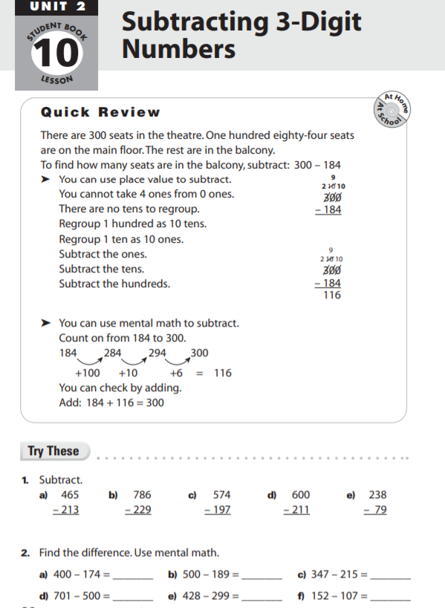

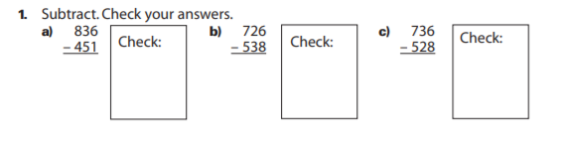

Subtract. Check your answers.

Subtract. Check your answers.

