Make various hopscotch games using different counting patterns.

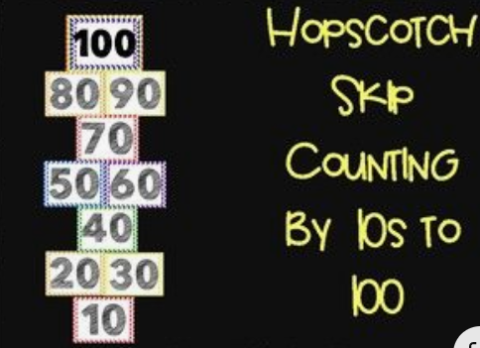

Finish these counting patterns on the catterpillars.
