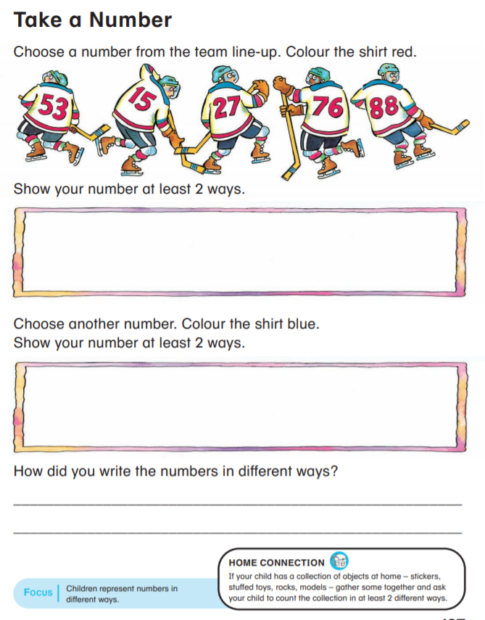

Count the base ten blocks.

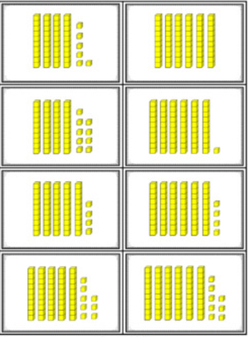
How many ways can you make these numbers drawing base ten blocks?

53 76 33 84 68

47 93 25 46 18

