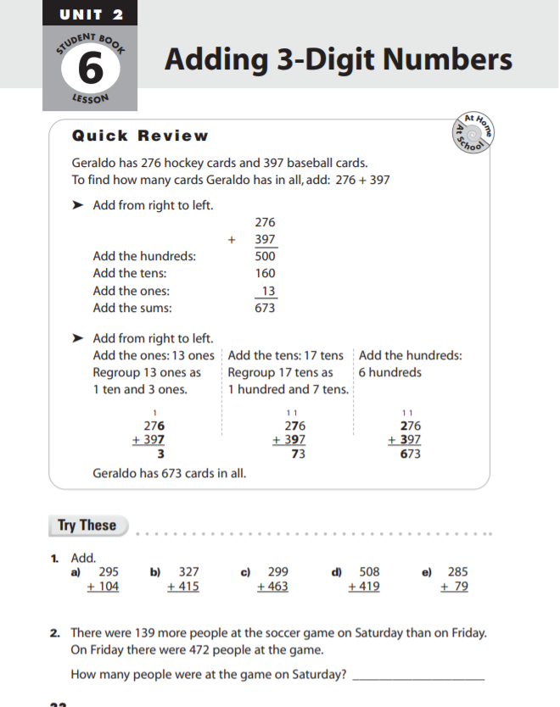

Answer 5 of the the questions below.

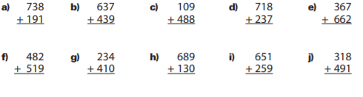

Answer the following questions.

